Detailed organizational chart showing the management structure that includes names and job title in INDIA.
- [Vishal Pratik]

UHGIS
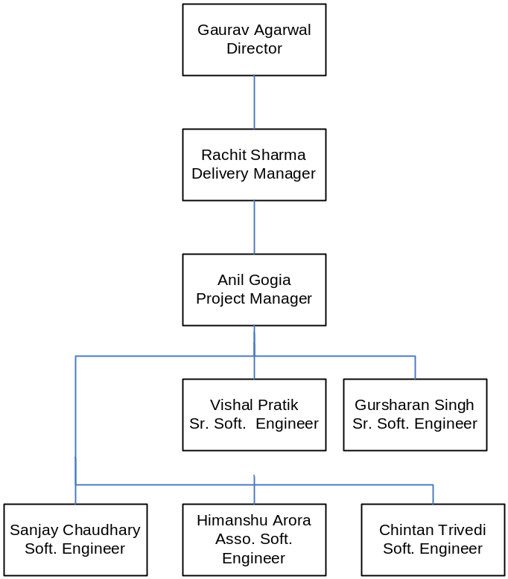

Abbreviations -

Sr. Soft Engineer → Senior Software Engineer
Soft. Engineer → Software Engineer
Assoc. Soft. Engineer → Associate Software Engineer

